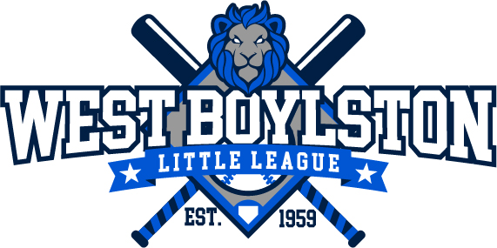 **West Boylston Little League** 

2023 Sponsor Enrollment Form

West Boylston Little League is a 501c3 non-profit, all volunteer, organization that operates baseball programs for the kids of West Boylston. Although WBLL collects registration fees, the expenses necessary to run our league far exceed our collected fees. Therefore, we must rely on our community to help support their kids! WBLL strives to teach the kids the fundamentals of baseball while providing the best possible team building experience. Your helpful, **Tax-Deductible**, sponsorship will enable WBLL to continue providing a terrific and gratifying baseball experience for the youth of West Boylston. We understand your business is subject to many requests for donations but we hope that you will consider WBLL a "donation for the youth of your community."

Thank you for your thoughtful consideration!

*-West Boylston Little League Board of Directors*

**-------------------------------------------------------------------------------------------------------------------------------**

**Sponsorship Options (please check all that apply):**

**~~Platinum Sponsor~~**~~:~~ **~~$400~~** (Majors and AAA divisions, limited spots available – **first come, first served!**)

* Sponsor name on back of team jersey or cap
* Commemorative plaque with team picture
* Sponsor name will be listed on WBLL Snack Shack
* Sponsor name will be listed on WBLL website
* Sponsor announced during Parade Day
* Sponsor sign along Goodale Park baseball fence

**Gold Sponsor**: **$250** (AA and A divisions, limited spots available – **first come, first served!**)

* Sponsor name on back of team jersey or cap
* Commemorative plaque with team picture
* Sponsor name will be listed on WBLL Snack Shack
* Sponsor name will be listed on WBLL website
* Sponsor announced during Parade Day
* Sponsor sign along Goodale Park baseball fence

**Silver Sponsor**: **$100**

* Sponsor name will be listed on WBLL Snack Shack
* Sponsor name will be listed on WBLL website
* Sponsor announced during Parade Day
* Sponsor sign along Goodale Park baseball fence

**Parade Banner**: **$150** ($100 for those who also purchased a sponsorship)

Our Little League Parade is held every spring at the start of the baseball season. For a $150 contribution ($100 for those who also purchased a sponsorship), your banner will be carried in the parade by baseball players. You must supply the banner. Please contact for maximum banner size.

**-------------------------------------------------------------------------------------------------------------------------------**

Sponsor Name: ___________________________________________________________

(As you would like it to appear)

Contact Person: ___________________________________________________________

Mailing Address: __________________________________________________________

Best Phone: _______________ Contact Email: ___________________________________

Website: _________________________________________________________________

If there is a WBLL player associated with this sponsorship, please list name(s) here: ________________________________________________________________________

Please submit form by March 1st along with check payable to:

**West Boylston Little League**

**PO Box 131**

**West Boylston, MA 01583**

For questions, please contact Jason Vitko at • jvitko@gmail.com • (203) 913-0909

• www.westboylstonlittleleague.org